**PIEP – ConfigurationPS**

**User Guide**

## VERSIONING AND CONTROL VALIDATION

VERSIONING HISTORY

|  |  |  |  |
| --- | --- | --- | --- |
| Version | AUTHOR | REVISION | Date |
| 1.0 | RCAS (CGI) | Creation | 05/06/2020 |
| 1.1 | RCAS (CGI) | Review prerequisite | 17/08/2020 |
|  |  |  |  |
|  |  |  |  |
|  |  |  |  |
|  |  |  |  |
|  |  |  |  |

VALIDATION

|  |  |  |
| --- | --- | --- |
| Version | Name | Date |
| 1.0 |  |  |
|  |  |  |

## DOCUMENT CONTENT

1. VERSIONING AND CONTROL VALIDATION 2

2. DOCUMENT CONTENT 3

3. SCRIPT DESCRIPTION 4

3.1 Objective 4

3.2 Prerequisite 4

4. USER GUIDE 5

4.1 Prepare the input file 5

4.2 Configure 01-ConfigurationPS.bat 5

4.3 Run ConfigurationPS 6

4.4 Clean the application 6

## SCRIPT DESCRIPTION

### Objective

**The purpose of ConfigurationPS is to extract the tags PI configuration into output csv files**.

The user provide the server name and a list of tags.

### Prerequisite

* Microsoft Powershell (1.0 or later).
* Package PI SMT 2018 or later.

## USER GUIDE

Copy the folder ConfigurationPS in your local machine/server : **D:\PI\Applications**\.

### 4.1 Prepare the input file

Get a list of the tags you want to extract configuration. Copy the list on the folder “.\input\Points.txt”, one tag per line. Example :

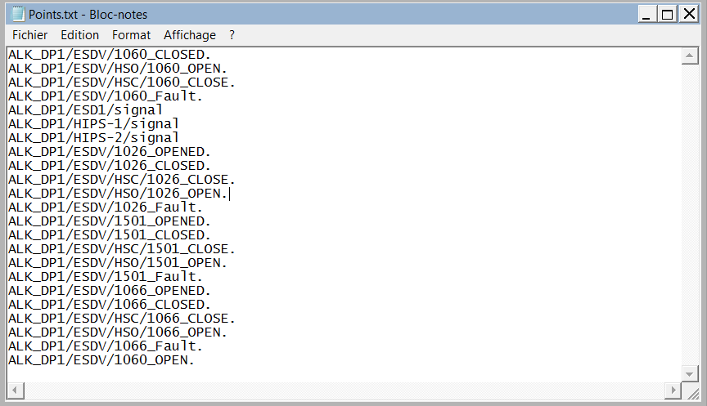

### 4.2 Configure 01-ConfigurationPS.bat

Edit the file “.\script\01-ConfigurationPS.bat”.

*cd ..*

*powershell.exe -file .\ConfigurationPS.ps1 -PIServerHost "SERVER_NAME"*

Modify the following parameters :

* **PIServerHost** : Name of the PI Server to extract tags (exemple : PI-CENTER-HQ)

Then save the modifications and close the file.

### 4.3 Run ConfigurationPS

**Run the script 01-ConfigurationPS.bat**.

You should have the following window opened. Let the program extract the configuration.

The logs are stored in the “.\logs” directory.

When the line “Press Enter to quit ConfigurationPS” appear, press Enter to quit.

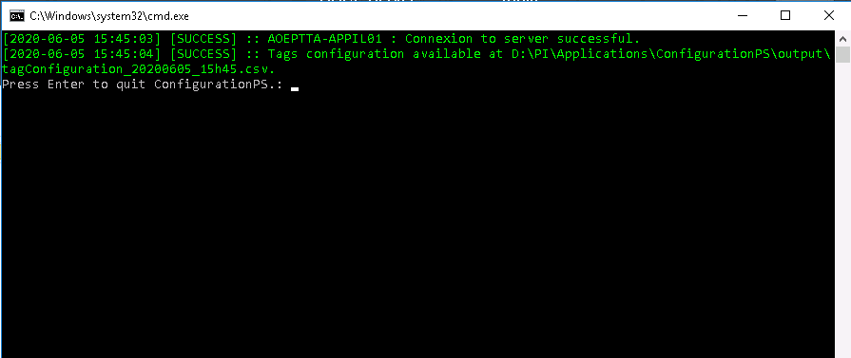

### 4.4 Clean the application

When the Configuration is finished, collect your configuration file in the “\output” directory.